**HomeWork 5**

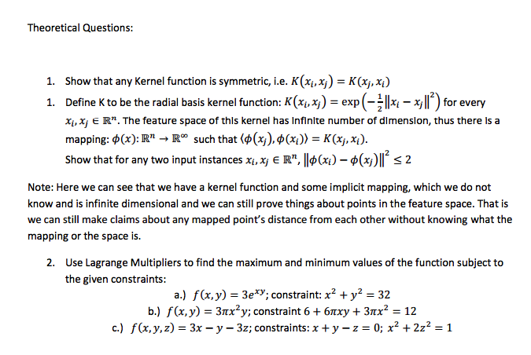

Answers

Question 1